COURSE SYLLABUS
BUS 795
Graduate Internship in Business Administration
Fall | 2023
Course Prefix & Number
Course Name
Term

Course Information

Instructor Information
Instructor: | Lyna M. Matesi, Ph.D.
Office: | Stevens Point (primary office): CPS Building room 320
Physical Office Hours: | Schedule as needed
Virtual Office Hours: | Schedule as needed
Cell Phone (Texting): | Cell: 715-340-6335 (text messages are welcome, be sure to tell me who you are )
E-mail: | lmatesi@uwsp.edu
Expected Instructor Response Time: | You can expect a response within 24 hours during weekdays. I tend to limit my online access during the weekends.

Course Information
Course Description: | Supervised training work program in a cooperating agency or business. Credit determined by MBA or intern director and business faculty. May be repeated with different experience.
Credits: | 1-9
Prerequisites: | MBA Office approval

Textbook & Course Materials
Required Text(s): | Provided in assigned modules.
Recommended Text(s): | Provided in assigned modules.
Other Readings: | Provided in assigned modules.
Other Required Materials / Applications: | Provided in assigned modules.

Course Technology
Course Website: | None besides our Canvas site.
Other Websites: | It is your responsibility to access links via the MBA Online Student Center housed in Canvas.
Course Delivery: | This course is delivered fully online. You must have high speed internet, headphones/microphone, and a web cam for this course. It is also important that you are ready to use Canvas, Zoom, and are sure to check your uwsp.edu email account every weekday.
Delivery Mode Changes: | Changes to course delivery may occur at any time during the term to address public health and safety concerns.
Canvas Support: | Click on the HELP button ( ) in the global (left) navigation menu and note the options that appear:  - Ask Your Instructor a Question  Submit a question to your instructor  - Use Ask Your Instructor a Question sparingly; technical questions are best reserved for Canvas personnel and help as detailed below.  - Chat with Canvas Support (Student)  Live Chat with Canvas Support 24x7!  - Chatting with Canvas Support (Student) will initiate a text chat with Canvas support. Response can be qualified with severity level.  - Contact Canvas Support via email  Canvas support will email a response  - Contacting Canvas Support via email will allow you to explain in detail or even upload a screenshot to show your difficulty.  - Contact Canvas Support via phone  Find the phone number for your institution  - Calling the Canvas number will let Canvas know that you're from UWSP; phone option is available 24/7.  - Search the Canvas Guides  Find answers to common questions  - Searching the Canvas guides connects you to documents that are searchable by issue. You may also opt for Canvas video guides.  - Submit a Feature Idea  Have an idea to improve Canvas?  - If you have an idea for Canvas that might make instructions or navigation easier, feel free to offer your thoughts through this Submit a Feature Idea avenue.  Self-train on Canvas through the Self-enrolling/paced Canvas training course.
UWSP Technology Support: | The Office of Information Technology (IT) provides a Service Desk to assist students with connecting to the Campus Network, virus and spyware removal, file recovery, equipment loan, and computer repair. You can contact the Service Desk via email at techhelp@uwsp.edu or at (715) 346-4357 (HELP) or visit: IT Service Desk.  For technology instruction sheets, online support videos, and other related resources, go to: UWSP Online Student Support.  The university also provides a Technology Tutoring service in which tutors meet with students one-on-one to provide technology assistance. To receive help of this nature visit: Tech Essentials Training.  Additional tools designed to help students taking online or hybrid courses can be found at: UWSP Online Student Orientation.

Learning Outcomes

Course Goals
Supervised training work program in a cooperating agency or business.

Course Learning Objectives
1. Design a project plan in coordination with an organization sponsor.
2. Identify project-based consulting processes and work to develop consulting skills.
3. Drive measurable project outcomes.

Academic Unit
SSBE Mission: | The UW-Stevens Point Sentry School of Business and Economics creates career ready graduates and leaders through applied learning. We serve the businesses, economy, and people of the greater Central Wisconsin region. We specialize in preparing students for success by providing professional development experiences, access to employers, and in-demand skills.  The SSBE achieves its mission by valuing:  - Talent development  - Lifelong learning  - Career preparation  - On the job experiences  - Community outreach  - Regional partnerships  - Continuous improvement
Accreditation Commitment: | SSBE is accredited by the Association to Advance Collegiate Schools of Business (AACSB), a designation earned by only 5 percent of world business schools. Accreditation instills a culture of continuously improving our programs through connections with local business leaders, alumni and the community.

Course Policies

Attendance
I am not tracking screen-time attendance in this course. If you complete all assignments on time, you are meeting the attendance requirement.

Late Work
I am happy to accept assignments early. If you need to extend an assignment deadline, please contact me by email before the deadline to ask for what you need.

Etiquette/Netiquette
When communicating, you should always:
- Treat your instructor and classmates with respect in email or any other communication.
- Feel free to address me by my first name, Lyna
- Use clear and concise language.
- Remember that all college level communication should have correct spelling and grammar.

Grading

Grading Scheme
Think of this course as a pass/fail course. If you complete all of the assignments, by the given deadlines you will pass and earn the maximum points possible. If you fail to complete assignments by the given deadline you will not pass and you will need to repeat the course.

Coursework Descriptions & Commentary

Exams
None

Quizzes
None

Assignments
Our schedule at a glance—
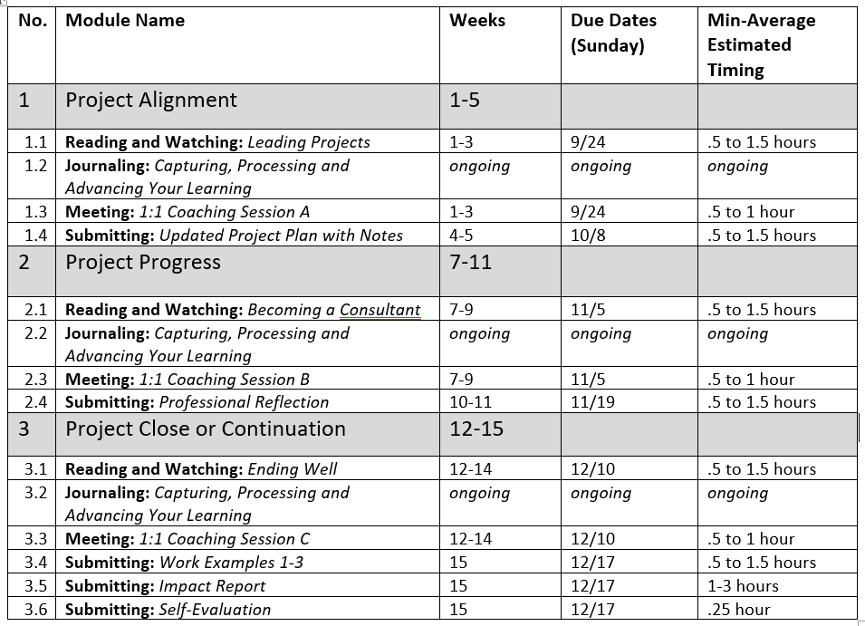

Schedule

Dates and Deadlines
The instructor will provide a tentative course schedule in a supplementary file. All provided course schedules are organized by week number in accordance with the official UWSP Academic calendar. A direct link to the UWSP Academic calendar can be found here: UWSP Academic Calendar.

Other Administrative Details

ADA / Equal Access for Students with Disabilities
The American Disabilities Act (ADA) is a federal law requiring educational institutions to provide reasonable accommodations for students with disabilities. Links to UWSP’s policies regarding ADA, nondiscrimination, and Online Accessibility (IT & Communication Accessibility) can be found at: UW Legal and Policy Information.

UW-Stevens Point will modify academic program requirements as necessary to ensure that they do not discriminate against qualified applicants or students with disabilities. The modifications should not affect the substance of educational programs or compromise academic standards; nor should they intrude upon academic freedom. Examinations or other procedures used for evaluating students' academic achievements may be adapted. The results of such evaluation must demonstrate the student's achievement in the academic activity, rather than describe his/her disability.

If modifications are required due to a disability, please inform the instructor and contact the Disability Resource Center (DRC) to complete an Accommodations Request form. The DRC is located in room 108 in the Collins Classroom Center (CCC). For more information, call 715-346-3365 email drc@uwsp.edu, or visit: Disability Resource Center

Nondiscrimination Statement
No person shall be discriminated against because of race, ethnicity, color, age, religion, creed, gender, gender identity, sexuality, disability, nationality, culture, genetic information, socioeconomic status, marital status, veteran’s status, or political belief or affiliation and equal opportunity and access to facilities shall be available to all. To address concerns regarding any of these issues please call 715-346-2606 or visit: Equal Opportunity Human Resources

SSBE Inclusivity Statement
It is my intent that students from diverse backgrounds and perspectives be well-served by this course, that students’ learning needs be addressed both in and out of class, and that the diversity that the students bring in and out of class be viewed as a resource, strength, and benefit. Every person has a unique perspective and we learn from hearing many of them, but not all perspectives are represented in course readings. So, learning depends upon all of you contributing to the class with your own opinions and perspectives. It is my intent to present materials and activities that are respectful of diversity: gender identity, sexuality, disability, age, socioeconomic status, ethnicity, race, nationality, religion, and culture. Your suggestions are encouraged and appreciated. Please let me know ways to improve the effectiveness of the course for you personally, or for other students or student groups.

If you have experienced a bias incident (an act of conduct, speech, or expression to which a bias motive is evident as a contributing factor regardless of whether the act is criminal) at UWSP, you have the right to report it. To do so, first go to the Hate Bias Response Team website, then click the button that corresponds to the appropriate campus, and finally complete and submit the report. You may also contact the Dean of Students office directly at dos@uwsp.edu.

Further information on UWSP’s commitment to an inclusive campus can be found here: https://www.uwsp.edu/equity-diversity-inclusion/?_ga=2.153240891.2061676798.1662211020-1646716202.1584973873

Religious Beliefs Accommodation
It is UW System policy (UWS 22) to reasonably accommodate your sincerely held religious beliefs with respect to all examinations and other academic requirements. A direct link to this policy can be found here: Chapter UWS 22 Accommodation of Religious Beliefs.

Help Resources
This section offers help resources relating to academic tutoring, healthcare, counseling, and other matter of student wellbeing. For help recourse related to technology use, please see section 1.4 above.

The Tutoring and Learning Center helps with Study Skills, Writing, Technology, Math, & Science. The Tutoring and Learning Center is located at 234 Collins Classroom Center (CCC). For more information, call 715-346-3568 or visit: Tutoring-Learning Center (TLC) at UWSP.

If you need healthcare, UWSP Student Health Service provides student-centered healthcare that empowers and promotes wellness for all UWSP students. Student Health Service is located on the 1st floor of Delzell Hall. For more information, call 715-346-4646 or visit: UWSP Student Health Services.

The UWSP Counseling Center is staffed with licensed mental health professionals dedicated to assisting students as they navigate difficult circumstances or resolve personal concerns. Therapy and consultation services are free of charge for registered students. The UWSP Counseling Center is located on the 3rd Floor of Delzell Hall. For more information, call 715-346-3553 or visit: UWSP Counseling Center.

In addition to the support services provided by Student Health Service and the UWSP Counseling, there are also professional support services available to students through the Dean of Students. Responding to students with care, concern, and resources is critical in supporting the success of our students and campus community, and therefore the Dean of Students maintains a list of resources that can provide support for a wide variety of situation. That list can be found here,
Dean of Students Resources. Moreover, the Office of the Dean of Students supports the campus community by reaching out and providing resources in areas where a student may be struggling or experiencing barriers to their success. Faculty and staff are asked to be proactive, supportive, and involved in facilitating the success of our students through early detection, reporting, and intervention. As such, an instructor may contact the Office of the Dean of Students if he or she senses that a student is in need of additional support beyond what the instructor is able to provide. Simply put, the Dean of Students is here to help. If you are ever unsure of what to do or who to contact, contact the Dean of Students Office at 715-346-2611 or visit them online at UWSP Office of the Dean of Students.

UWSP students may also share a concern directly if they or another member of our campus community needs support, is distressed, or exhibits concerning behavior that is interfering with the academic or personal success and/or the safety of others. Please report any concerns of this nature at: UWSP Dean of Students Anonymous Reports.

Emergency Response Guide
In the event of an emergency, follow UWSP’s emergency response procedures. For details on all emergency response procedures, please go to: UWSP Emergency Guidebook pdf.

UWSP Community Bill of Rights and Responsibilities
UWSP values a safe, honest, respectful, and inviting learning environment. In order to ensure that each student has the opportunity to succeed, a set of expectations has been developed for all students, staff, and faculty. This set of expectations is known as the Rights and Responsibilities document, and it is intended to help establish a positive living and learning environment at UWSP. For more information, go to: UWSP Community Bill of Rights and Responsibilities.

University Attendance Policy
In addition to the course attendance policies determined by the instructor (noted above if applicable), the university provide standard guidelines by which students are to abide. All exceptions to the course attendance policy or the university guidelines should be documented in writing. A link to the university’s attendance guidelines can be found at: University Attendance Policy.

University Drop Policy
You are expected to complete the courses for which you register. If you decide you do not want to take a course, you must follow the procedures established by the university to officially drop the course. If you never attend or stop attending a course and fail to officially drop, you will receive an F in the course at end of the semester. A link to the university’s drop policy can be found at: University Drop Policy.

Academic Honesty
UW System policy (UWS 14) states that students are responsible for the honest completion and representation of their work, for the appropriate citation of sources, and for respect of others' academic endeavors. Students suspected of academic misconduct will be asked to meet with the instructor to discuss the concerns. If academic misconduct is evident, procedures for determining disciplinary sanctions will be followed as outlined in UWS 14. A direct link to this policy can be found here: Chapter UWS 14 Student Academic Disciplinary Procedures.

Grade Reviews/Appeals
A formal grade appeal, also known as a Grade Review, can be requested in instances when the student feels that he or she was not provided a syllabus with a grading scale in a timely manner (i.e., the end of the second week of classes) and/or the instructor did not stick with the grading scale published in the syllabus. Questions of whether or not the instructor appropriately graded one or more of the course assignments, quizzes, exams, etc. are not matters to be decided by a formal grade appeal, but rather should be taken up with the instructor directly. Information on grade reviews can be found in the University Handbook, Chapter 7, Section 5. A link to the university’s policies on non-academic misconduct can be found at: UWSP Grade Reviews/Appeals.

Non-Academic Misconduct
Information on non-academic misconduct can be found in Chapters 17 and 18 of the Student Rights and Responsibilities Document. A link to the university’s policies on non-academic misconduct can be found at: UWSP Non-Academic Misconduct.

Confidentiality
Under FERPA, students cannot remain anonymous in a class. Students are permitted to know who else is in their class.

Learning requires risk-taking and sharing ideas. Please keep your classmates’ ideas and experiences confidential outside the classroom unless permission has been granted to share them.

This course may require students to post their work online using applications or services that have not been approved by UW-system. In this situation, the students work will only be viewable only by his or her classmates. None of the work submitted online will be shared publicly. Some assignments require account creation for online programs. The instructor of this course will not share your academic records (grades, student IDs). Confidentiality of student work is imperative, so you should not share the work of your peers publicly without their permission. By participating in these assignments, you are giving consent to sharing of your work with others in this class and you recognize there is a small risk of your work being shared online beyond the purposes of this course. Examples of additional risks include data mining by the company providing the service, selling of your email to third parties, and release of ownership of data shared through the tool. Please contact your instructor prior to the due date if you wish not to participate in these online assignments due to confidentiality concerns.

UW-System approved tools meet security, privacy, and data protection standards. For a list of approved tools, go to: UWS Digital Learning Environment External Application Integration Requests. Tools not listed on the website linked above may not meet security, privacy, and data protection standards. If you have questions about tools, contact the UWSP IT Service Desk at 715-346-4357. Links to the Terms of Use and Privacy Polices for tool used at UWSP be found at: Terms of Use and Privacy Policies for Tools Used

Here are steps you can take to protect your data and privacy:
- Use different usernames and passwords for each service you use
- Do not use your UWSP username and password for any other services
- Use secure versions of websites whenever possible (HTTPS instead of HTTP)
- Have updated antivirus software installed on your devices

Additional resources regarding information security at UWSP can be found at: https://www.uwsp.edu/infosecurity/Pages/default.aspx.

It is important for students to understand that faculty are required to report any incidents of maltreatment, discrimination, self-harm, or sexual violence they become aware of, even if those incidents occurred in the past, off campus, or are disclosed as part of a class assignment. This does not mean an investigation will occur if the student does not want that, but it does allow the university to provide resources to help the student continue to be successful.

Intellectual Property - A Guide to Student Recording & Sharing Class Content
Lecture materials and recordings for this class are protected intellectual property at UW-Stevens Point. Students in this course may use the materials and recordings for their personal use related to participation in this class. Students may also take notes solely for their personal use. If a lecture is not already recorded, you are not authorized to record my lectures without my permission unless you are considered by the university to be a qualified student with a disability requiring accommodation. [Regent Policy Document 4-1] Students may not copy or share lecture materials and recordings outside of class, including posting on internet sites or selling to commercial entities. Students are also prohibited from providing or selling their personal notes to anyone else or being paid for taking notes by any person or commercial firm without the instructor’s express written permission. Unauthorized use of these copyrighted lecture materials and recordings constitutes copyright infringement and may be addressed under the university's policies, UWS Chapters 14 and 17, governing student academic and non-academic misconduct.

Sample Coursework Permission
The instructor may wish to use a sample of your work or some of the feedback you provide on the course in future teaching or research activities. Examples: showing students an example of a well-done assignment; analyzing student responses on a particular question; discussing teaching techniques at a conference. If your coursework or feedback is used, your identity will be concealed. If you prefer not to have your work included in any future projects, please send the instructor an e-mail indicating that you are opting out of this course feature. Otherwise, your participation in the class will be taken as consent to have portions of your coursework or feedback used for teaching or research purposes.

Revision Clause
This syllabus, the provided schedule, and all aforementioned coursework, are subject to change. It is the student’s responsibility to check the course website for corrections or updates to the syllabus. Any changes will be clearly noted in a course announcement or through email.

